# Introduction

# The Church Financial Record Keeping application is a web-based application designed to record donations made to the Church. This user manual assists the user by providing a step by step guide on how to:

* Login to the application
* Add/Edit/Delete members
* Add/ Edit/Delete funds
* Add/Edit/Delete donations made to the church
* Generate reports

This document has the following sections. Section 2 gives information on the system requirements and installation instructions of the software, section 3 describes the login process, section 4 describes how to add/edit/delete members, section 5 describes how to add/edit/delete funds, section 6 describes how to add/edit/delete donations, finally, section 7 shows how to generate reports.

**2. System Requirements**

The following are the minimum system requirements:

* Windows 7/8/8.1/10
* Dual core Processor
* 1 GB RAM
* 40 GB Hard Disk
* One of the following web browsers: Microsoft Internet Explorer or Google Chrome or Mozilla Firefox.
* Eclipse IDE for Java EE developers
* MySQL Server

**2.2 Client Installation -MySQL Server**

The installation and configuration for Church Record Keeping software requires MySQL database in order to function. My SQL should be installed and configured before the application is installed and used.

**Eclipse**

Eclipse should be installed and running in client machine before application is used. It can be downloaded online free of charge. The church Financial Record Keeping project will be integrated into eclipse

1. **Log In**

Figure 1 shows the login screen.

To get started, you must login using provided user credentials by entering a valid **username** and **password** in their respective fields and click “Sign In” button as shown in Screen 1.

If the user has forgotten login password, then the user needs to click on **need help with your Password?** in Screen 1. Now a message appears describing on how to retrieve user credentials by contacting system administrator.

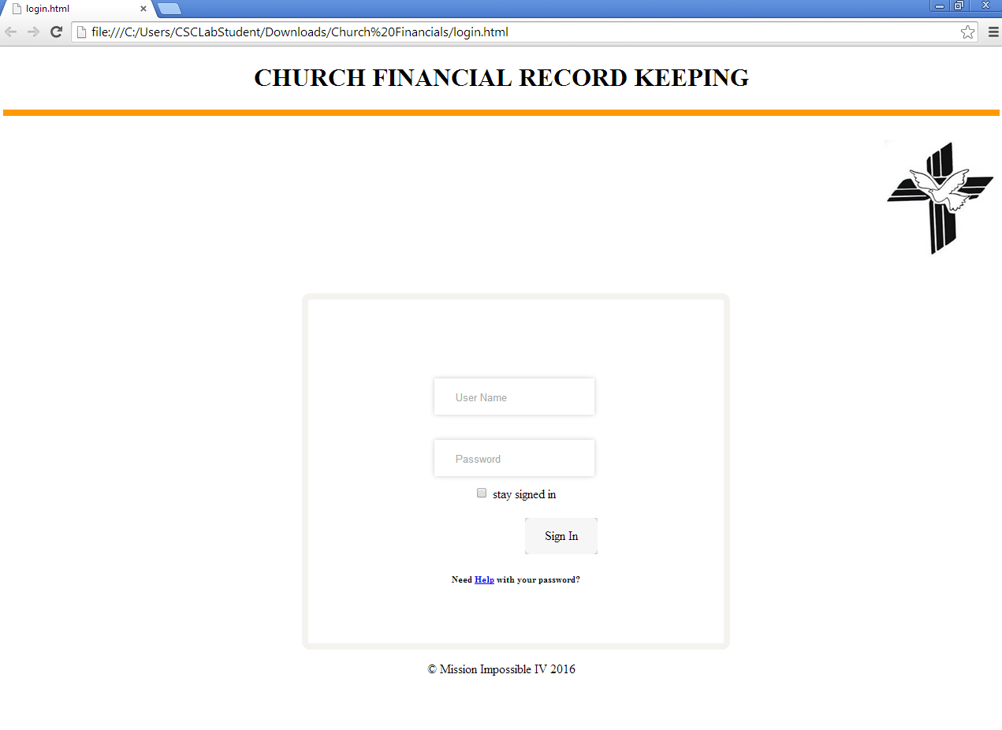

**Figure1. Login**

1. **Site Navigation**

Once the user has successfully logged into the system he/she can navigate through the features using the menu bar at the top. The menu bar has access to the following application functions.

* Member: User can Add/Edit/Delete members in this section
* Fund: User can Add/Edit/Delete funds in this section
* Donation: User can Add/Edit/Delete donations in this section
* Report: User can generate reports of donations from this section
  1. **Member**

Click on **Member** tab from menu bar at the top. You will see two tabs, **Add** and **View**. Select the appropriate tab in order to add/edit/delete members. Figure2 shows the member screen.

**4.1.1 To Add a New Member**

As shown in Screen 2, click on **Add New Member** tab and do the following:

* Enter the **Envelope No., Last Name, First name Address Line1, Address Line2, (optional) City, Zip code.** in their respective fields Once completed, you must
* Click **AddMember** button to add the member.
* If you wish to view the members on record, click on **View** button.

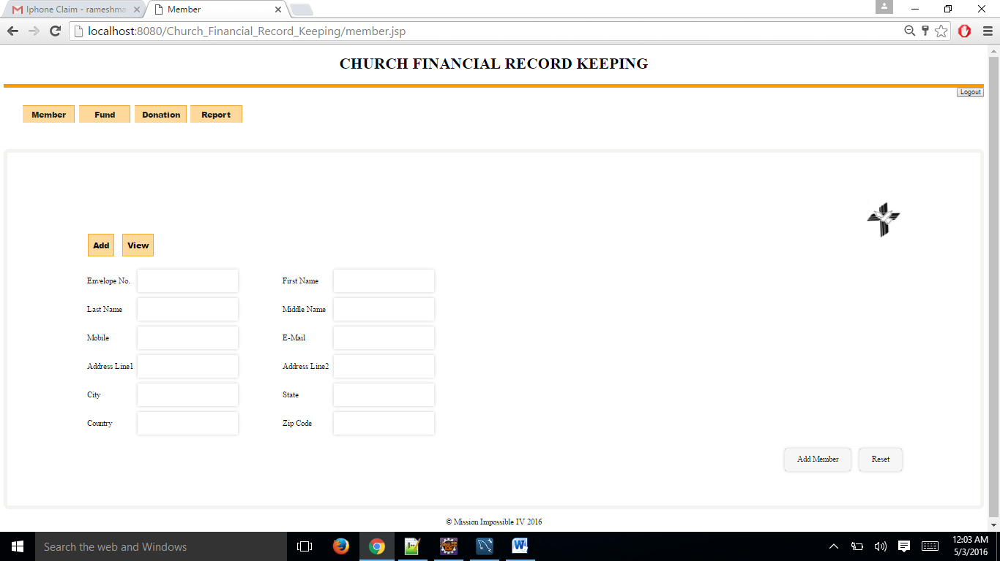

**Figure2. Add Member**

**4.1.2 To Edit a Member**

Figure3 shows the edit member screen

As shown in Screen 3, click on **View** tab. You will see a list of members in a grid. To

edit a member’s information, do the following:

* Search for the member by entering his/her envelope number and hit the return key.
* You will see an update button associated with each member record in the grid.
* Click on the member filed then edit the details of member and click update button.

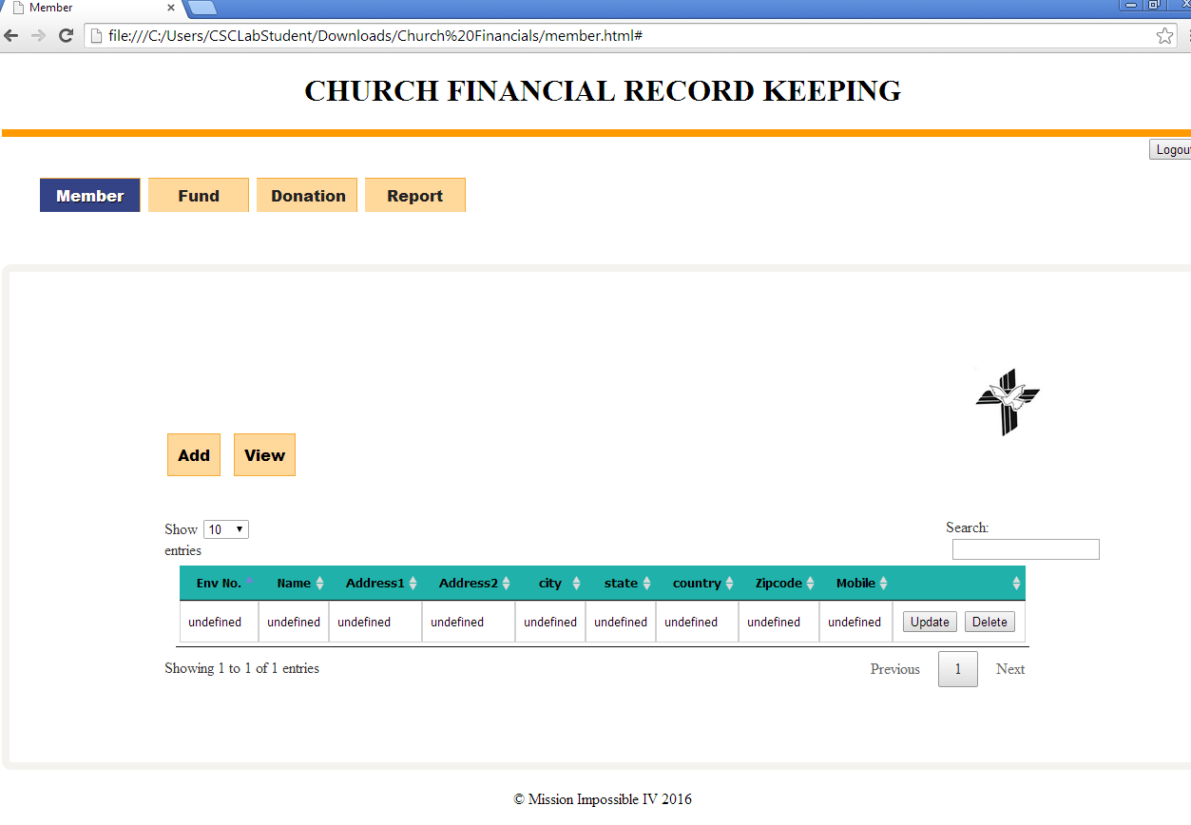

**Figure3. Edit Member**

**4.1.3 To Delete a Member**

As shown in Screen 4, click on **View** tab. You will see a list of members in a grid. In order to delete a member information do the following:

* Search for the member by entering his/her envelope number in the search box field and hit the return key.
* You will see a delete button associated with each member record in the grid.
* Click on the delete button and edit the details of member in the page.
* Click **save** button to save the changes made.



**Figure4.Delete Member**

1. **Fund**

Click on **Fund** tab from menu bar at the top. You will see two tabs, **Add and** **View**. Select the appropriate tab in order to create/edit/delete funds. Figure5 shows the funds screen

**5.1To Create a New Fund**

As shown in Screen 5, click on the **Add tab** and do the following:

* Enter the **Fund Number** in the fund number field.
* Enter the **Fund Name** in the fund name field.
* Click **AddFund** button to add the created fund.
* Click on **reset** button if you would like to erase all the details that you entered.
* If you wish to view the funds on record, click on **View** button.

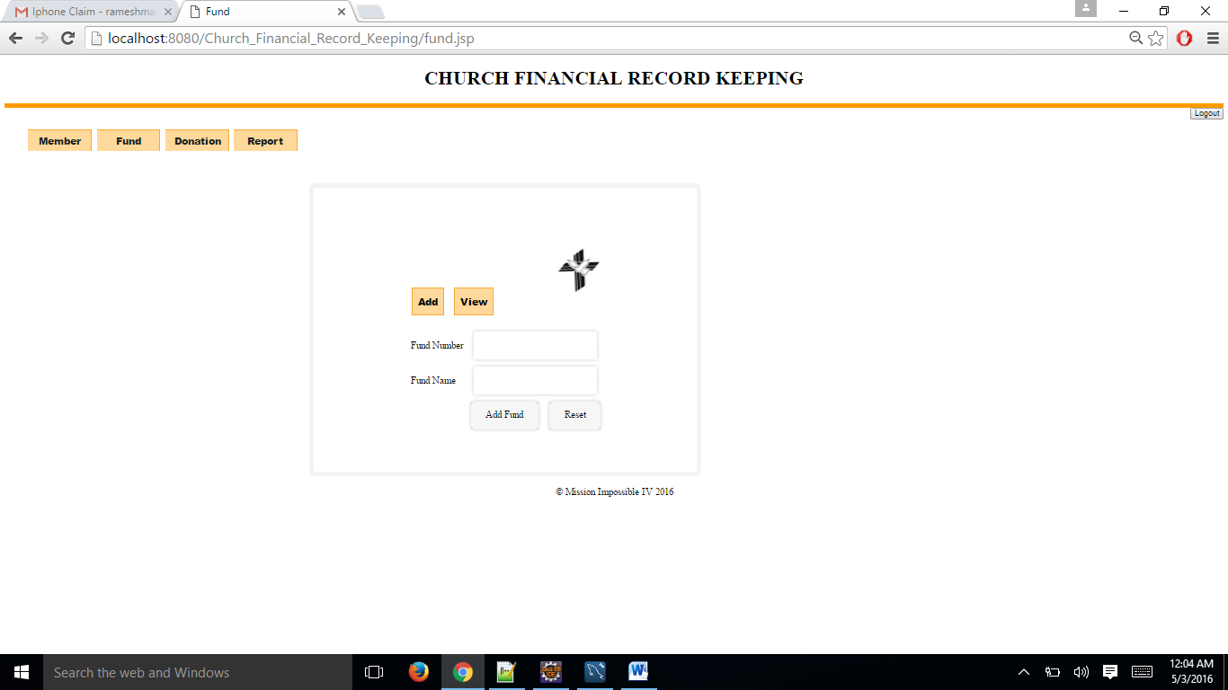

**Figure5. Create fund**

**5.2 To Edit a Fund**

Figure6 shows the edit fund screen.

As shown in Screen 6, click on the **View** tab. You will see a list of funds in a grid. In order to edit fund information, do the following:

* Search for the fund by entering the details (like the Fund Number or Fund Name) and hit the return key.
* You will see an update button associated with each fund record in the grid.
* Edit the details of the fund in the page and click on the update button.

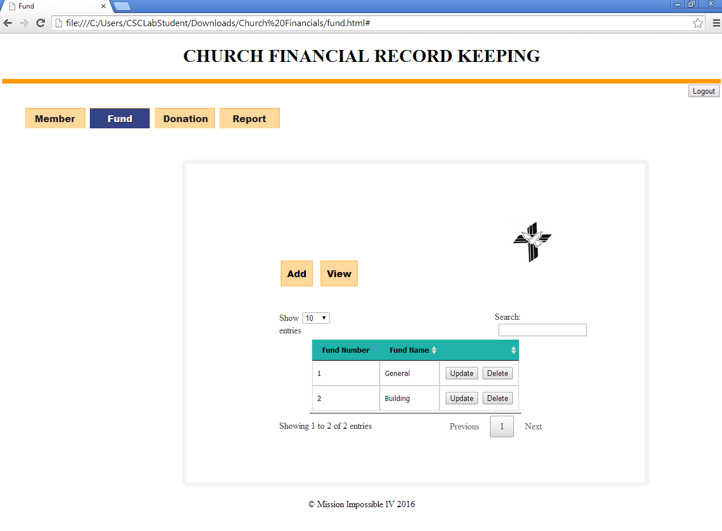

**Figure 6. Edit Fund**

**5.3 To Delete a Fund**

Figure 7 shows the delete fund screen.

As shown in Screen 7, click on the **View** tab. You will see a list of funds in a grid. In order to delete a fund information, do the following:

* Search for the fund by entering the details (like the Fund Number or Fund Name)
* You will see a delete button associated with each fund record in the grid.
* Click on the delete button to delete the fund.



**Figure7.Delete Fund**.

**6. Donation**

Click the **Donation** tab from menu bar at the top. You will see two tabs, **Add and** **View**. Select the appropriate tab in order to create/edit/delete donations. Figure 8 shows the donations screen.

* 1. **To Create a New Donation**

As shown in Screen 8, click on **Add** tab and do the following:

* Enter the **Envelope Number, fund name and amount.** Select the date from calendar and **Money Type, Date** from the menu list in their respective fields.

Click the **AddDonation** button to add the donation.

* To view donations, click the **View** tab.

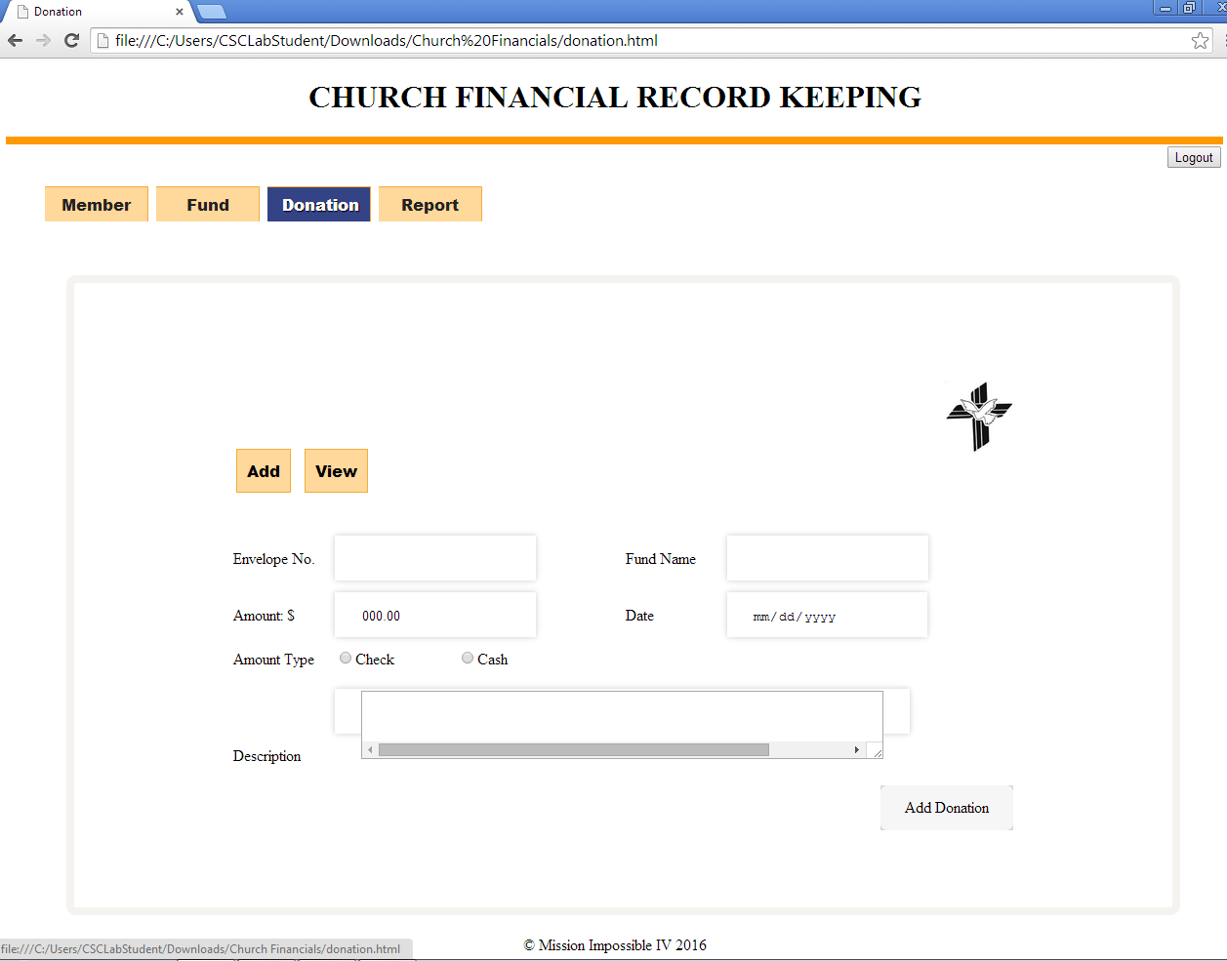

**Figure 8.Create Donation**

**6.2 To Edit a Donation**

Figure 9 shows the edit donations screen.

As shown in Screen 9, click the **View** tab. You will see a list of donations in a grid. In order to edit donations information, do the following:

* Search for the donation by entering the details (like the envelope Number or Fund Name) and hit the return key.
* You will see an update button associated with each donation record in the grid.
* Edit the details of the donation and click update button.

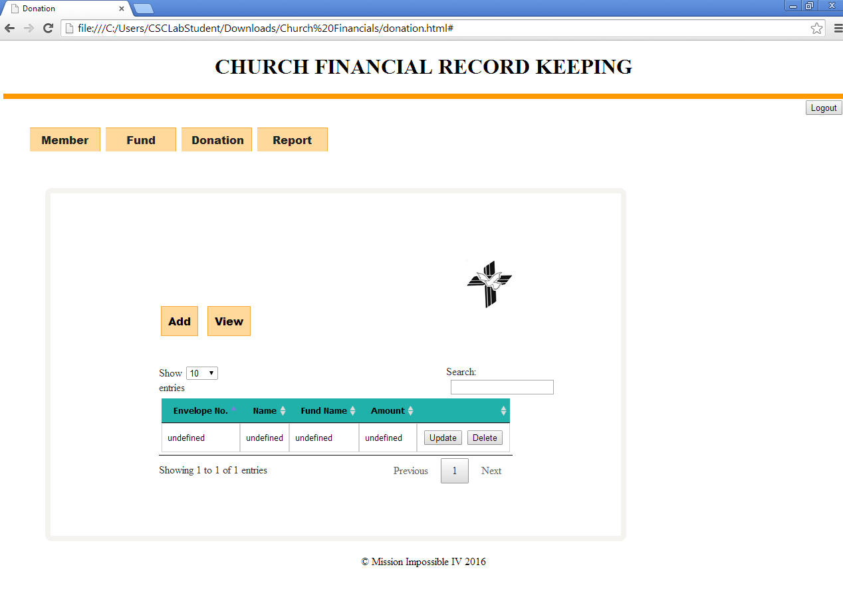

**Figure 9.Edit Donation**

**6.3 To Delete a Donation**

Figure 10 shows the delete donation screen.

As shown in Screen 10, click the **View** tab. You will see a list of donations in a grid. In order to delete donations information, do the following:

* Search for the donation by entering the details (like the envelope Number or Fund Name) in the search area and hit return key.
* You will see a delete button associated with each donation record in the grid.
* Click the delete button to delete details of the donation.



**Figure 10.Delete Donation**

1. **Reports**

Figure 11 shows the reports screen.

Click the **Report** tab from menu bar at the top (Annual reports, monthly reports, weekly reports or daily reports) and do the following:

* Select **From Date** and **To Date** in their respective fields to specify specific period.
* Click **Member** tab to generate report for that particular member.
* Click on **search** button to display the report in the grid.
* Click on print button to print the report.
* Repeat this for other types of reports.

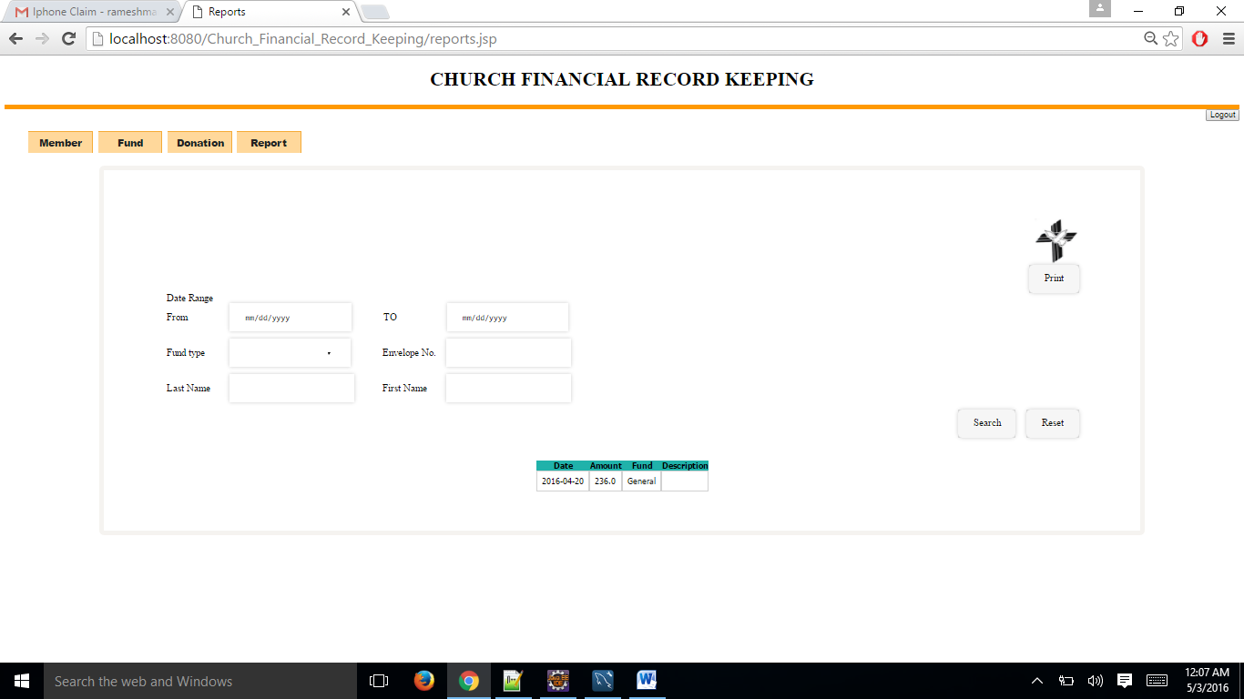

**Figure 11. Report**

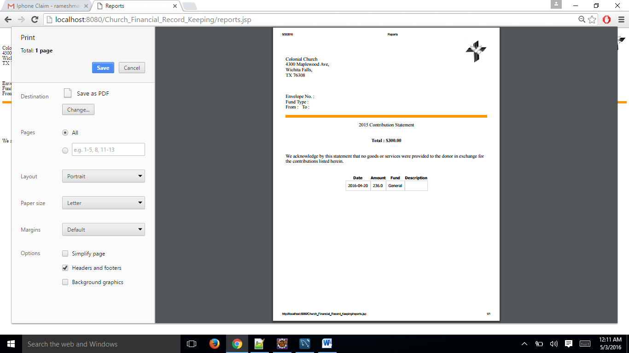

**Figure 12. Sample report**

1. **Log Out**

Remember to log out when you have finished. Click the logout button located at the top-right corner of the page and close your browser (all windows).

**9 Support**

Contact MI4 team for any help with the application via Phone: 9407826476 or email: matikuclive@gmail.com,rameshmannava4u@gmail.com,majesh00@gmail.com, divya.h.shree12@gmail.com.

**10. Glossary**

Client- The party for which services is rendered.

Database- Files containing the collection of data for the software.

MySQL- Database management software

Eclipse- An integrated development environment (IDE).

Microsoft Windows- A family of operating systems from Microsoft Corporation.

1. **References**

[1] “United States Department of Housing and Urban Development” user manual template, from Google: https://portal.hud.gov/hudportal/documents/huddoc? id= DOC _15160.doc

[2] Somerville, I., Software Engineering 9th edition book, Pearson (March 2004).

[3] SCORS and SOCS user manual drafts provided by Professor Dr. Stringfellow.